A Project
ON
“Demo Testing Website”


Course: Software Quality Engineering + Lab (SE-343 / SE-343L)
Project Marks: 40
Instructor: Ubaid Bin Zafar
Group (max 2): ____________________
Students (names & reg#): M Attaullah (233665), M Waleed Qasim (233694)
Date: __________ Evaluator: __________ Total (/40): _______ /40
Sign: __________

Scoring legend (fast)
- Excellent = 100% of item marks
- Good = 75% of item marks
- Fair = 50% of item marks
- Poor = 25% of item marks
- Missing = 0%

Rubric
# | Item — what to check quickly | Max | Tick
1 | Demo & Execution — chosen app link provided; original behavior shown; tests executed on deployed app (live demos before/after where applicable). | 8 | ☐ Excellent ☐ Good ☐ Fair ☐ Poor ☐ Missing
2 | Test Cases (quantity) — at least 3 test cases for each testing technique used (evidence: template + test data). | 6 | ☐ Excellent ☐ Good ☐ Fair ☐ Poor ☐ Missing
3 | Use of Metrics — each required metric used once for its specified purpose, calculations shown, and brief result interpretation. | 5 | ☐ Excellent ☐ Good ☐ Fair ☐ Poor ☐ Missing
4 | Function Point Analysis (FPA) — FP computed for 2–3 screens with working counts & steps shown. | 5 | ☐ Excellent ☐ Good ☐ Fair ☐ Poor ☐ Missing
5 | FP Complexity Classification — complexity computed for at least one FP from each category (e.g., External Input, External Output, External Interface). | 3 | ☐ Excellent ☐ Good ☐ Fair ☐ Poor ☐ Missing
6 | Testing Technique Rationale & Application — short description of each technique and how it was applied to chosen test cases. | 4 | ☐ Excellent ☐ Good ☐ Fair ☐ Poor ☐ Missing
7 | Test Artifacts & Templates — test case templates filled, trace to requirements/metrics, and screenshots/logs of test runs. | 3 | ☐ Excellent ☐ Good ☐ Fair ☐ Poor ☐ Missing
8 | Documentation & Submission Compliance — uploaded in required template, signed scanned copy available, URL/link included in report. | 3 | ☐ Excellent ☐ Good ☐ Fair ☐ Poor ☐ Missing
9 | Originality & Group Rules — work is individual (or group ≤2) and not copied (verbal check + obvious signs of plagiarism). | 1 | ☐ Excellent ☐ Good ☐ Fair ☐ Poor ☐ Missing
10 | Presentation & Viva / Q&A — clarity, time management, ability to explain choices & answer 2 quick questions (demo-focused). | 2 | ☐ Excellent ☐ Good ☐ Fair ☐ Poor ☐ Missing

Open Cart Demo Website

1. ABSTRACT/Summary

Chosen Application: OpenCart Demo Website
Short Description:
OpenCart is an online shopping demo website where users can browse products, add them to a shopping cart, and complete a purchase through the checkout process. The website provides a simple interface for exploring product categories and viewing product details.
Core Features:
- User Login: Users can log in with demo credentials to access personalized features.
- Product Browsing: Users can view a list of products in various categories and check product details.
- Shopping Cart: Users can add, remove, and update product quantities in the cart.
- Checkout Process: Users can simulate the checkout process including billing and order confirmation.
- Product Reviews: Users can view sample product reviews (if provided in demo).
- Responsive Design: The website works on desktop and mobile screen sizes.
- Demo-only Functionality: Allows exploration of basic e-commerce operations without actual transactions.
URL: https://demo.opencart.com

2. Testing Technique Rationale & Application

1. Black Box Testing
- Description:
Black Box Testing checks the functionality of the application without knowing its internal code.
- Application:
We tested features like login, product search, add to cart, and checkout by providing inputs and observing outputs without looking at the backend code.
2. Functional Testing
- Description:
Functional Testing verifies whether the system works according to functional requirements.
- Application:
We verified that users can log in, browse products, add items to cart, and complete checkout as expected on OpenCart.
3. System Testing
- Description:
System Testing checks the complete system as a whole after integration.
- Application:
The entire OpenCart website was tested to ensure all modules work together properly, such as login → cart → checkout.
4. End-to-End Testing
- Description:
End-to-End Testing validates the complete user workflow from start to end.
- Application:
A full purchase flow was tested: login → product selection → add to cart → checkout
→ order confirmation.
5. Smoke Testing
- Description:
Smoke Testing checks whether the basic functionalities of the system are working.
- Application:
We checked if the homepage loads, login page opens, product pages display, and cart is accessible.
6. Sanity Testing
- Description:
Sanity Testing ensures that major functionalities work after small changes or releases.
- Application:
After basic navigation, we verified login, add to cart, and checkout work correctly without deep testing.
7. Regression Testing
- Description:
Regression Testing ensures that existing functionalities are not broken after changes.
- Application:
Previously tested features like login and checkout were re-tested to ensure they still
work properly.
8. Re-testing
- Description:
Re-testing is done to confirm that previously failed test cases are fixed.
- Application:
Any failed scenario (such as invalid login) was tested again with correct inputs to
confirm proper behavior.
9. Usability Testing
- Description:
Usability Testing checks how user-friendly the application is.
- Application:
We evaluated ease of navigation, readability of text, button placement, and clarity of messages on OpenCart.
10. Security Testing (Basic)
- Description:
Security Testing checks the system for basic security issues.
- Application:
We tested login with invalid credentials and ensured sensitive information like
passwords is masked.

11. Performance Testing (Observation-Based)
- Description:
Performance Testing checks how fast the system responds.
- Application:
Page load time for homepage, product page, and checkout was observed under normal usage conditions.

12. Exploratory Testing
- Description:
Exploratory Testing is performed without predefined test cases to discover defects.
- Application:
We freely navigated the website to identify broken links, UI issues, and unexpected behavior.

13. GUI Testing
- Description:
GUI Testing verifies the visual elements of the user interface.
- Application:
We checked alignment of buttons, consistency of fonts, images display, and layout
across pages.

14. Positive Testing
- Description:
Positive Testing verifies the system works correctly with valid inputs.
- Application:
Valid login credentials and correct checkout information were used to ensure successful operations.

15. Negative Testing
- Description:
Negative Testing verifies how the system behaves with invalid inputs.
- Application:
Invalid login details and empty form submissions were tested to check error handling.

16. Compatibility / Cross-Browser Testing
- Description:
Compatibility Testing checks whether the application works on different browsers.
- Application:
OpenCart was tested on Chrome and Firefox to ensure consistent behavior.
17. Accessibility Testing
- Description:
Accessibility Testing ensures the application can be used by all users.
- Application:
We checked font readability, contrast, keyboard navigation, and link visibility.

18. Load Testing (Assumption-Based)
- Description:
Load Testing checks system behavior under expected user load.
- Application:
We assumed 100 concurrent users browsing products and observed expected stable behavior.

19. Stress Testing (Assumption-Based)
- Description:
Stress Testing checks system behavior beyond normal limits.
- Application:
We assumed very high user traffic and analyzed possible system slowdown or failure.

20. Volume Testing (Assumption-Based)
- Description:
Volume Testing checks system behavior with large data.
- Application:
We assumed a large number of products and orders stored in the database.

21. Scalability Testing (Assumption-Based)
- Description:
Scalability Testing checks how the system handles increased workload.
- Application:
We assumed increased users and product listings and evaluated expected performance.
22. Concurrency Testing (Assumption-Based)
- Description:
Concurrency Testing checks system stability when multiple users access it simultaneously.
- Application:
We assumed multiple users adding products to cart at the same time.

23. Recovery Testing (Assumption-Based)
- Description:
Recovery Testing checks system recovery after failure.
- Application:
We assumed system crash during checkout and evaluated expected recovery behavior.

24. Installation Testing
- Description:
Installation Testing checks whether the application installs correctly.
- Application:
We assumed OpenCart installation on a server and verified expected working after setup.

25. Alpha Testing
- Description:
Alpha Testing is performed by developers before release.
- Application:
We assumed in-house testing of OpenCart features before making it public.

26. Beta Testing
- Description:
Beta Testing is performed by real users in real environments.
- Application:
We assumed feedback from real users using OpenCart demo in real usage conditions.

2. Function Points

I have chosen 3 screens for calculating the raw function points based on weights and then the adjusted function points also according to that as given below:
- Screen 1: Login Page (Box)
FP Component | Count | Weight | UFP | Notes
External Input (EI) | 4 | 4 | 16 | Email, Password, forget, click login,
External Output (EO) | 2 | 5 | 10 | Login success/error msg
External Inquiry (EQ) | 1 | 4 | 4 | Forgot Password check
Internal Logical File (ILF) | 1 | 10 | 10 | Users database
External Interface File (EIF) | 0 | 7 | 0 | No external interface

- Total Raw Function Point= 36
GSC Rating (Representative Note: EI- Email/Password)
GSC | Rating (0–5)
Data communications | 1
Distributed functions | 2
Performance | 4
Heavily used configuration | 3
Transaction rate | 2
Online data entry | 1
End-user efficiency | 1
Online update | 1
Complex processing | 3
Reusability | 1
Installation ease | 2
Operational ease | 1
Multiple sites | 2
Facilitate change | 4
CAV | 26

- To calculate the adjusted Function Point for EI – Email/ Password
Adjusted FP = Raw FP * (0.65 + 0.01 * CAV)
= 36 * (0.65 +0.01 * 26)
= 36 * 0.91

Adjusted FP = 32.76

- Screen 2: Product Detail Page (MacBook box)
FP Component | Count | Weight | UFP | Notes
External Input (EI) | 15 | 4 | 60 | Add to Cart, Quantity, Review submission
External Output (EO) | 12 | 5 | 60 | Product details, Price info
External Inquiry (EQ) | 1 | 4 | 4 | Stock availability query
Internal Logical File (ILF) | 1 | 10 | 10 | Product database
External Interface File (EIF) | 0 | 7 | 0 | No external interface

- Total Raw Function Point= 134

GSC Rating (Representative Note: EO - Product Details)
GSC | Rating (0–5)
Data communications | 2
Distributed functions | 3
Performance | 4
Heavily used configuration | 2
Transaction rate | 3
Online data entry | 2
End-user efficiency | 3
Online update | 2
Complex processing | 3
Reusability | 2
Installation ease | 1
Operational ease | 3
Multiple sites | 2
Facilitate change | 3
CAV | 35

- To calculate the adjusted Function Point for EO - Product Details
Adjusted FP = Raw FP * (0.65 + 0.01 * CAV)
= 134 * (0.65 +0.01 * 35)
= 134 * 1.00

Adjusted FP = 134

- Screen 3: Checkout Page
FP Component | Count | Weight | UFP | Notes
External Input (EI) | 11 | 4 | 44 | Billing, Shipping, Payment, Coupon code
External Output (EO) | 8 | 5 | 40 | Order confirmation, Error message
External Inquiry (EQ) | 1 | 4 | 4 | Shipping Calculation
Internal Logical File (ILF) | 1 | 10 | 10 | Order database
External Interface File (EIF) | 0 | 7 | 0 | -

- Total Raw Function Point= 98

GSC Rating (Representative Note: EI – Billing Info)
GSC | Rating (0–5)
Data communications | 3
Distributed functions | 3
Performance | 4
Heavily used configuration | 2
Transaction rate | 3
Online data entry | 4
End-user efficiency | 4
Online update | 3
Complex processing | 4
Reusability | 3
Installation ease | 1
Operational ease | 4
Multiple sites | 2
Facilitate change | 3
CAV | 43

- To calculate the adjusted Function Point for EO - Product Details
Adjusted FP = Raw FP * (0.65 + 0.01 * CAV)
= 98 * (0.65 +0.01 * 43)
= 98 * 1.08

Adjusted FP = 105.84

3. Metrices

I have chosen 3 screens for calculating the Halstead Metrics and other metrices as given below:
1. Halstead Metrics
- Screen 1: Login Page (Box)
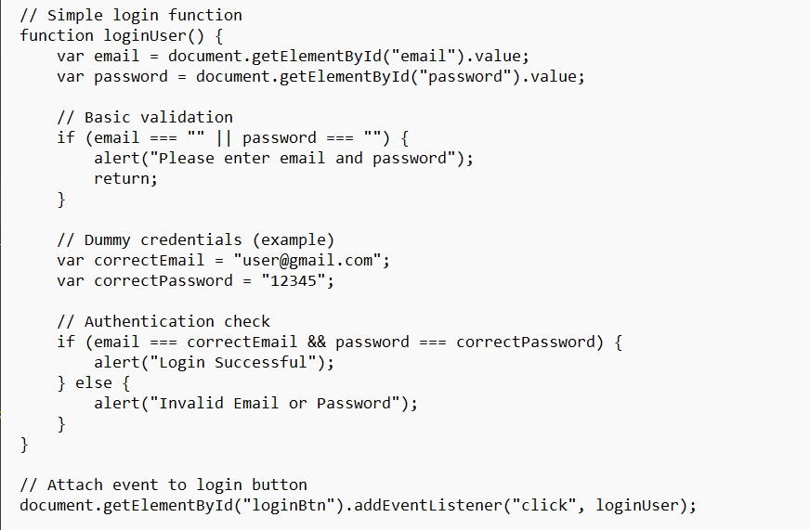
  - Identify operands & operators

    - Distinct Operators (n₁) = function () {} = . ; If, === || Alert return var " " (empty string) document. getElementById addEventListener Total =15
    - Distinct Operands (n₂) loginUser Email document "email" Value password password Please enter email and password correctEmail user@gmail.com correctPassword 12345 Login Successful Invalid Email or Password loginBtn Total=15
    - Total Operators (N₁) = Total=54
    - Total Operands (N₂) = Total = 26

  - Compute Halstead Core Metrics
    - Program length N= N1 + N2 = 54+28= 82
    - Program Vocabulary n= n1 + n2 = 15 +15 = 30
    - Estimated length N ^ = n1 log2 n1 + n2 log2 n2
= 15 × log₂(15) + 15 × log₂(15)
= 15 × 3.9069 + 15 × 3.9069
= 58.6035 + 58.6035
= 117.207
    - Purity Ratio = N ^ / N =17.207 / 82 = 1.429
    - Volume V= N log2 n = 82 × log₂ (30) = 82 × 4.9069 = 402.366
    - Difficulty D= n1/ 2 * N2 / n2 = (15/2) × (28/15) = 7.5 × 1.867 = 14.0
    - Program Effort E = D*V= 14.0 × 402.366 = 5633.124

2. Size-Oriented Metrics
Metric | Value | Description
Lines of Code (LOC) | 25 | Physical lines with code
Source Lines of Code (SLOC) | 16 | Executable statements only

- Screen 2: Product Detail Page (MacBook box)

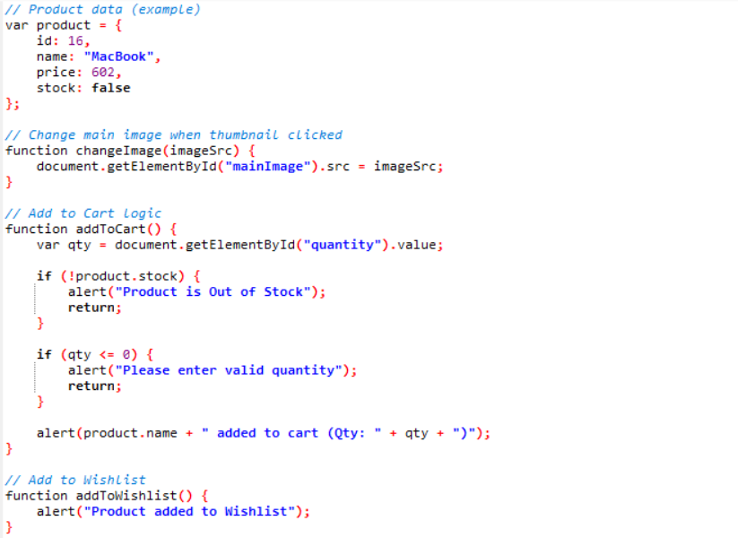
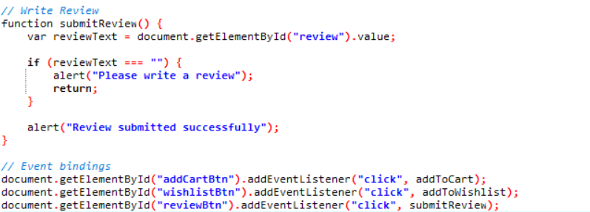
1. Halstead Metrics
  - Identify operands & operators

    - Distinct Operators (n₁) = Total =22
    - Distinct Operands (n₂) = Total=32
    - Total Operators (N₁) = Total=58
    - Total Operands (N₂) = Total = 45

  - Compute Halstead Core Metrics
    - Program length N= N1 + N2 = 22 + 32 = 54
    - Program Vocabulary n= n1 + n2 = 58 + 45 = 103
    - Estimated length N ^ = n1 log2 n1 + n2 log2 n2
= 22 × log₂ (22) + 32 × log₂ (32)
= 22 × 4.4594 + 32 × 5.0
= 98.1068 + 160
= 258.1068
    - Purity Ratio = N ^ / N = 258.1068 / 103 = 2.506
    - Volume V= N log2 n = 103 × log₂ (54) = 103 × 5.7549 = 592.755
    - Difficulty D= n1/ 2 * N2 / n2 = (22/2) × (45/32) = 11 × 1.40625 = 15.469
    - Program Effort E = D*V= 15.469 × 592.755 = 9,168.526

2. Size-Oriented Metrics
Metric | Value | Description
Lines of Code (LOC) | 45 | Physical lines with code
Source Lines of Code (SLOC) | 36 | Executable statements only

- Screen 3: Checkout Page

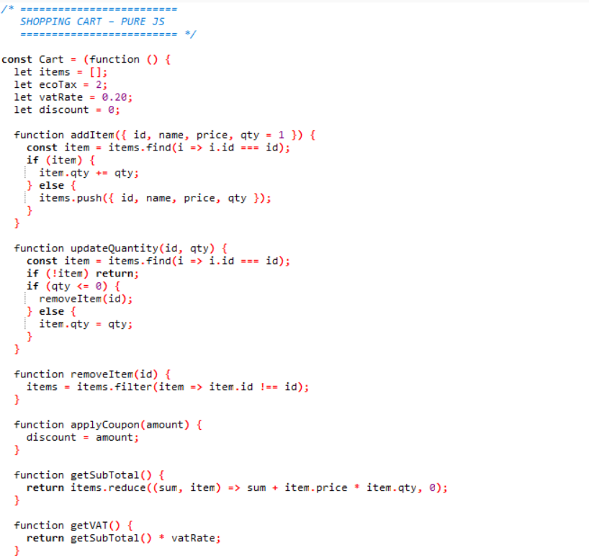
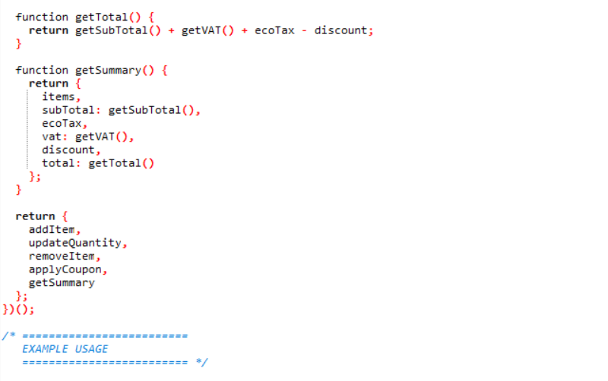

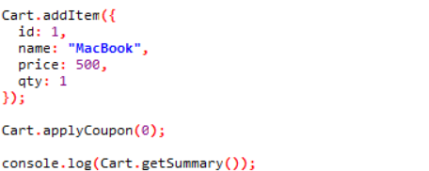

1. Halstead Metrics
  - Identify operands & operators

    - Distinct Operators (n₁) = Total = 35
    - Distinct Operands (n₂) = Total= 43
    - Total Operators (N₁) = Total= 148
    - Total Operands (N₂) = Total = 89

  - Compute Halstead Core Metrics
    - Program length N= N1 + N2 = 148 + 89 = 237
    - Program Vocabulary n= n1 + n2 = 35 + 43 = 78
    - Estimated length N ^ = n1 log2 n1 + n2 log2 n2
= 35 × log₂ (35) + 43 × log₂ (43)
= 35 × 5.1293 + 43 × 5.4263
= 179.5255 + 233.3309
= 412.8564
    - Purity Ratio = N ^ / N = 412.8564 / 237 = 1.742
    - Volume V= N log2 n = 237 × log₂ (78) = 237 × 6.2854 = 1489.640
    - Difficulty D= n1/ 2 * N2 / n2 = (35/2) × (89/43) = 17.5 × 2.069= 36.2215
    - Program Effort E = D*V= 36.2215× 1489.640 = 53,957.767

2. Size-Oriented Metrics
Metric | Value | Description
Lines of Code (LOC) | 63 | Physical lines with code
Source Lines of Code (SLOC) | 57 | Executable statements only

4. Complexity ANal

Code 1 is the LEAST COMPLEX because:
- Smallest Volume (402.366)
- Lowest Difficulty (14.0)
- Least Effort required (5,633.124)
- Fewest lines of code (25 LOC, 16 SLOC)
Code 2 is MEDIUM COMPLEX because:
- Moderate Volume (592.755)
- Slightly higher Difficulty (15.469)
- Medium Effort (9,168.526)
Code 3 is the MOST COMPLEX because:
- Largest Volume (1,489.640)
- Highest Difficulty (36.222)
- Maximum Effort (53,957.767)
Conclusion:
- Complexity Ranking: Code 1 < Code 2 < Code 3
- Code 1 is the least complex (simplest)
- Code 3 is the most complex

